Shopify Order Processing & Financial Automation
n8n | Shopify | Google Drive | Google Sheets | JavaScript

Project Overview
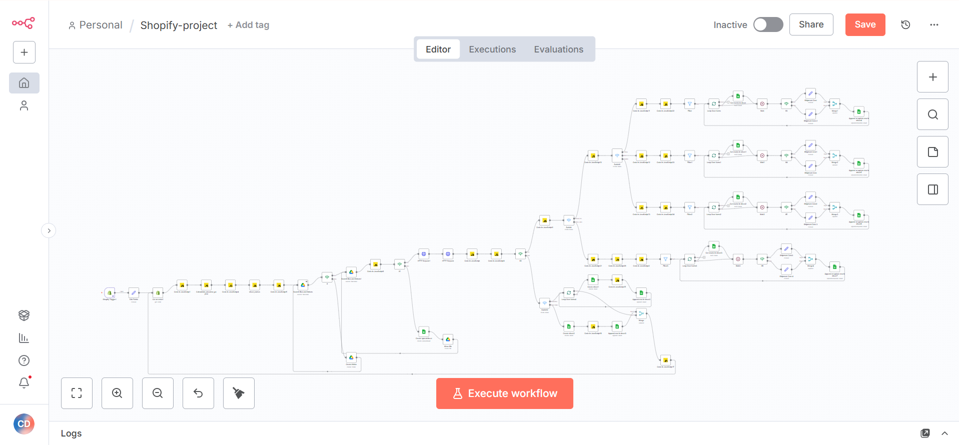
Built an automated Shopify order processing system that handles order data, product costs, financial calculations, and reporting without manual spreadsheet work.
The workflow processes each order, calculates the relevant costs and profit, and automatically organizes the data into the correct Google Drive and Sheets structure.

Workflow
The system:
• Captures new Shopify orders automatically
• Categorizes products based on product information
• Retrieves variant and cost data from Shopify
• Calculates fees, payouts, shipping, packaging, and net profit or loss
• Identifies repeat customers and applies the required calculations
• Determines the correct folder, spreadsheet, and sheet for each order
• Creates missing folders, files, or sheets when required
• Maintains consistent spreadsheet structures
• Adds or updates order records in the appropriate sheet

Financial Tracking
Each order can be processed against:
• Product cost
• Platform fees
• Payment fees
• Streamer payouts
• Shipping costs
• Packaging costs
• Net profit or loss

Technology
• n8n
• Shopify API
• Google Drive API
• Google Sheets API
• JavaScript
• REST APIs

Result
A scalable order processing and financial tracking system that removes manual accounting work, keeps order data organized, and provides a consistent view of costs, payouts, and profitability as order volume grows.

